Focus Group for App Design

|  |  |  |  |
| --- | --- | --- | --- |
|  | App Design1(Marvel) | App Design 2 ( | App Design 3 |
| Overall Design | 9 | 6 | 9 |
| User Experience | 9 | 5 | 8 |
| Ease of use | 8 | 7 | 8 |
| Usefulness | 9 | 5 | 10 |

App 1

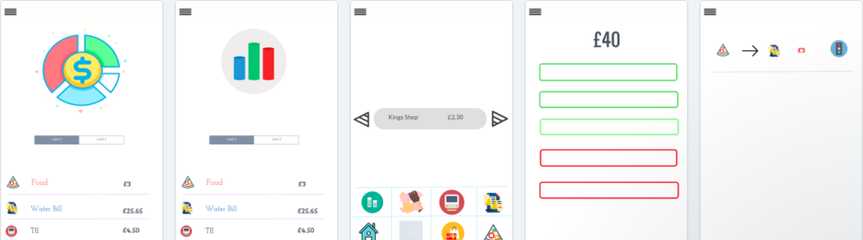

App 2

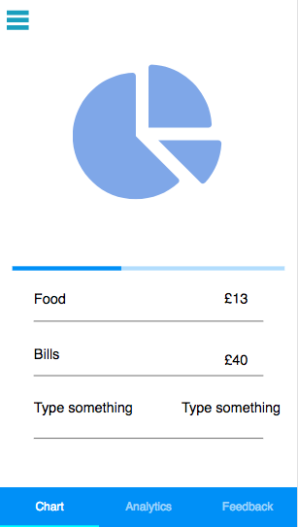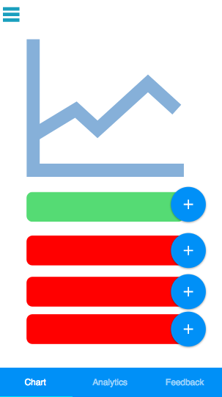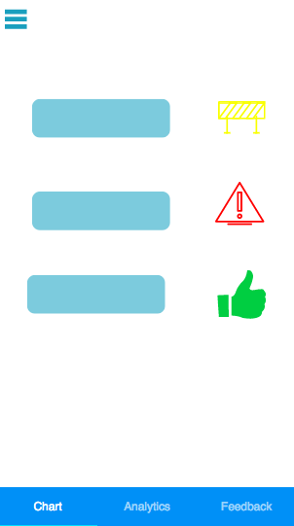

App 3

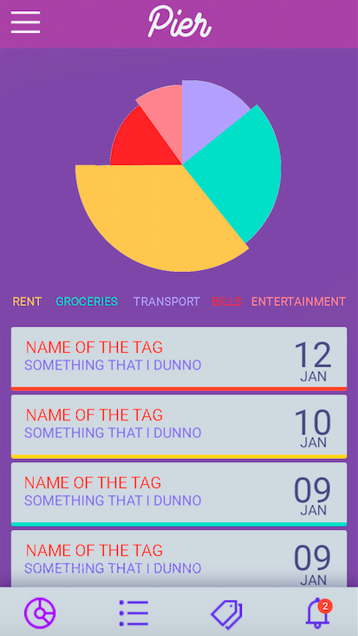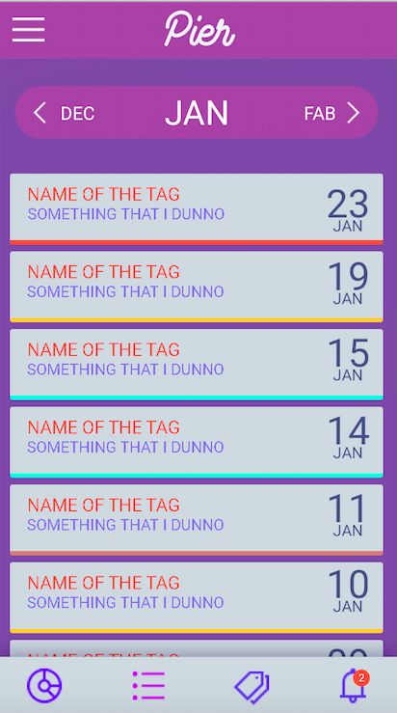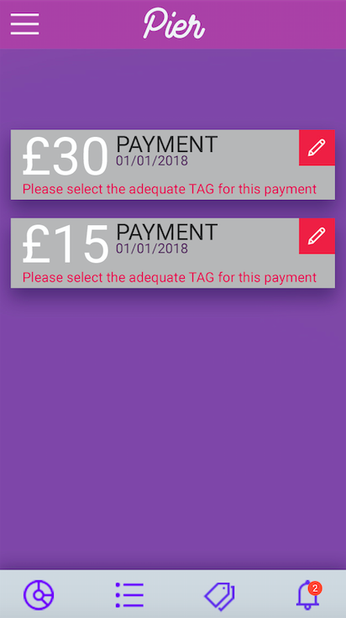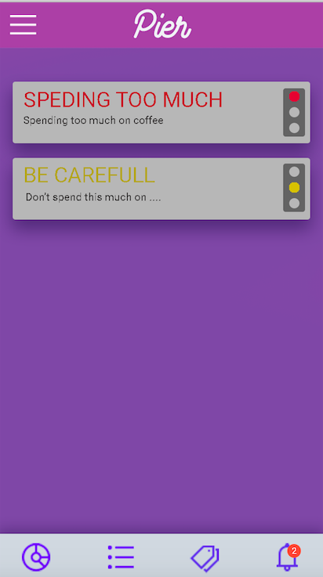

**Breakdown –**

Which App has the best breakdown?

App 1

What would you change/add to make it better in your opinion?

Name on the app

**Data Analytics -**

Which App has the best Data Analytics ?

App3

What would you change/add to make it better in your opinion?

- if you can add type of spending

**Tags-**

Which App has the best Tags?

APP 1

What would you change/add to make it better in your opinion?

**Alerts**

Which App has the best Alerts?

App 1

What would you change/add to make it better in your opinion?

Better graphics otherwise app1

**Input Method**

Method 1 – Leave to side bar-

Method 2 – Put in tab - tab

**Any other comments/ Suggestions**

I think it fits the purpose of the application. However improve graphics.